

**-- MANUAL FOR FLIGHT ATTENDANTS TULIP AIR --**

# DEVELOPED BY TEAM 7 2022

Version 1.0

INDEX

STARTING THE IN-FLIGHT ENTERTAINMENT SYSTEM........................................................... 3

ADMIN PAGE......................................................................................................................... 4

MEDIA CONTENT …............................................................................................................... 4

UPDATING THE APPLICATION............................................................................................... 5

STARTING THE IN-FLIGHT ENTERTAINMENT SYSTEM

Power on the flight system:

***For the stand alone version (no screen):***

Press the physical green ‘on’ button.

The application itself should get started on boot. If this is not the case, contact you IT-department.

***For the screen set up:***

The screen should be automatically turn on when the plane turns on (integrated electronic system). Move your finger over the screen to activate it.

In case the app did not manually boot and a keyboard is present: the following set of commands should fix the situation:

|  |  |
| --- | --- |
| Open up the terminal | **CTRL + ALT + T** |
| Change directory: | **cd /Desktop/EYF/team07** |
| Manually start the application. | **npm start** |

|  |  |
| --- | --- |
| Port in use | **Npx kill-port [port number]** |
| Override automatic startup | **pm2 unstartup systemd**  **CHECK THE ABOVE STEPS FRO MANUAL BOOTING THE APP** |

ADMIN PAGE

The admin page is for the overview of orders. Passengers are blocked from this view and should never have access to this page. Do not distribute the login details outside colleagues.

Logging on to the admin panel:

Press the profile option in the left corner.

On the profile page, make sure to select ‘Tulip air employee’.





Enter the following credentials:

SEATNUMBER: 9999  
FIRST NAME: admin  
LAST NAME: admin  
PASSWORD: admin

And press ‘submit’.

Checking orders

When logged in as the admin user, you can check the (processed) orders from passengers onboard. Simply press the order button on the right to get a list of all the orders (foods, drinks and items).

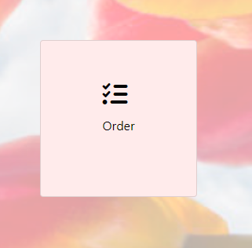

* After submitting the order, you will get a list of all orders the passenger made. The list of orders will look like this:

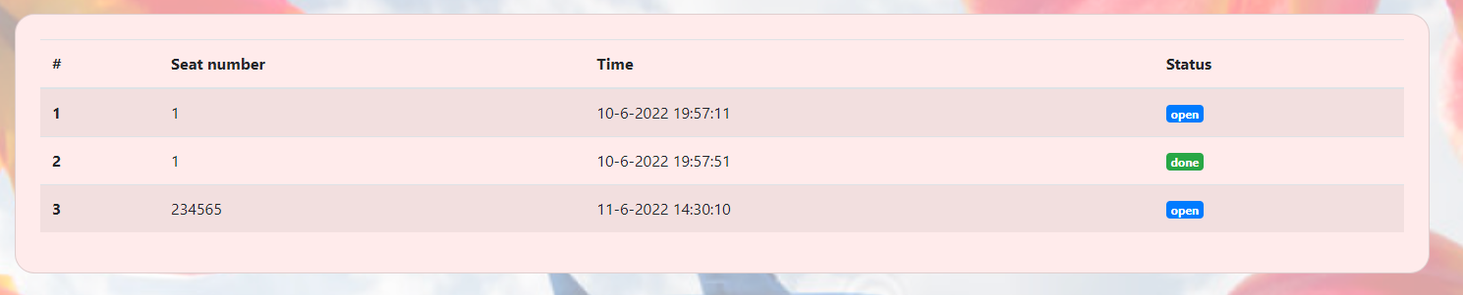

By pressing 'Order' you will get an overview with order specifics.

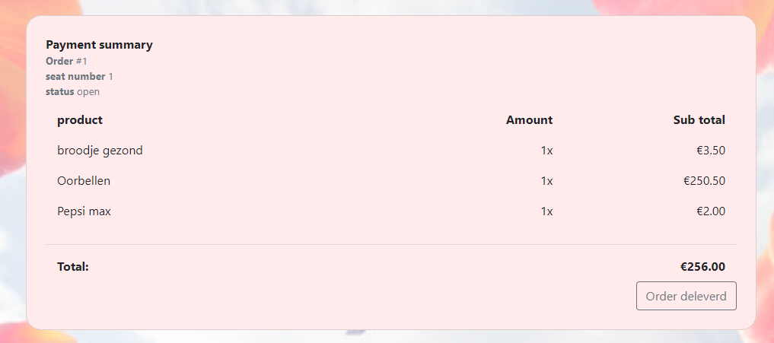

After delivering the products, please press the button 'Order delivered'. This button will close the order and change the order's status to done.

The change the variety of items, please contact your IT-department with the desired items.

MEDIA CONTENT

The media content is brought on board with the head-steward via USB or SSD-disk.

Simply plugging the USB / SSD disk will update the content of the media section.

UPDATING THE APPLICATION

The latest version of the application can be found on <https://gitlab.fdmci.hva.nl/eyf/2122/team07>

You will need credentials for this. The head steward can request these from the IT-department.

Updating the application should not be part of the cabin crew's tasks, but in case of an immediate patch (must be done on the screen version):

|  |  |
| --- | --- |
| Connect the keyboard |  |
| Open the terminal | **CTRL + ALT + T** |
| UPDATE COMMAND | **GIT PULL MASTER** |
| RESTART THE APP | **SUDO REBOOT** |